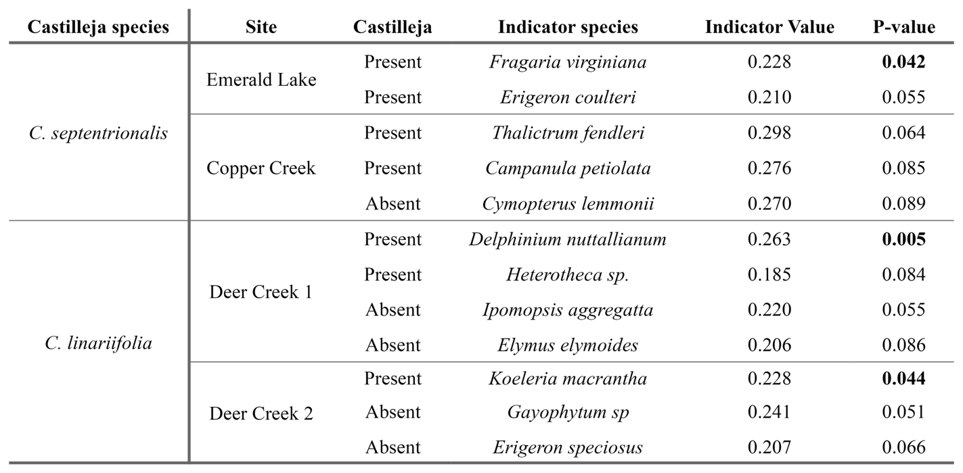**Main figures**

**Table II.** Results of site-level indicator species analysis for all species with alpha < 0.1. P-values for statistically significant species (< 0.05) are bolded.

**Table I.** Site and *Castilleja* species for observational paired plots.

**Figure 2.** Non-metric multidimensional scaling (NMDS) plot based on Bray-Curtis dissimilarities. Points represent individual plots, with Castilleja presence plots in green and Castilleja absence plots in brown. Castilleja species are represented by shape. The stress for this ordination solution is 0.15. Sites are denoted by ellipses and short codes. Almont (AL), Deer Creek 1 (DC1), Deer Creek 2 (DC2), Johnson Hill (JH), Emerald Lake (EL), Avery Picnic (AP), and Copper Creek (CC).

**Figure 1. A)** Shannon Diversity, **B)** Species richness, and **C)** Species evenness of the underlying plant community across seven sites and three species. *Castilleja* cover values are removed, and indices are separated by year. Points represent the mean and standard error for *Castilleja*-present plots in blue and *Castilleja*-absent plots in yellow.

**Figure 3.** Figure table of host species and functional groups for Rocky Mountain *Castilleja* species. The methods of host identification, including Nearest Neighbor (NN), Observed Haustoria (HA), and Indicator Species Analysis (ISA), are presented as positive (**+**) symbols in the Source column. Average Cover and occurrence data for host species are broken down by presence and absence plots for all species that occurred within the study sites for each species.

**Figure 4.** Nearest Neighbor (NN) plots for all sites and Castilleja species in 2023 (yellow circles) and 2024 (green diamonds). **A)** Castilleja septentrionalis at Emerald Lake, **B)** Castilleja septentrionalis at Avery Picnic **C)** Castilleja septentrionalis at Copper Creek, **D)** Castilleja linariifolia at Deer Creek 1 & 2, **E)** Castilleja linariifolia at Johnson Hill, and **F)** Castilleja chromosa at Almont. Points are colored by year. Points that fall above or below the predictive intervals (dashed blue lines) represent species that were significantly more (or less) abundant as a NN than expected by chance alone. The brown line represents the linear model out and standard errors.